✅ TeXstudio Template V2.1
Jocelyne Smith, 11 Feb 2026

✅ Before using this template, please ensure that:
- You have followed the installation guide provided with the template. This ensures that TeX Live and TeXstudio are correctly installed and configured.
- You have read Getting Started with Your Research Proposal Template in LaTeX, which provides general guidance on using the template.
⚠️This document only describes changes and usage specific to Version 2.0 of the template.

🔹 1. The Role of main.tex (Always Compile This)
main.tex is the master file.
You should always compile from main.tex, never from chapter files or packages.
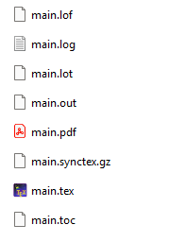
Why this matters:
- It loads the document class, packages, and global settings.
- It controls page layout, fonts, spacing, and numbering.
- It ensures cross-references, citations, and the table of contents work correctly.
✅ Even if you are editing Chapter 3 or the cover page, you still compile from main.tex.

🔹 2. Editing Content: “Go to Source”
Each chapter, appendix, or major section is stored in its own .tex file.
To edit a section:
- Left-click inside the section in the PDF preview or editor
- Choose “Go to Source”
- The correct file will open automatically at the right location
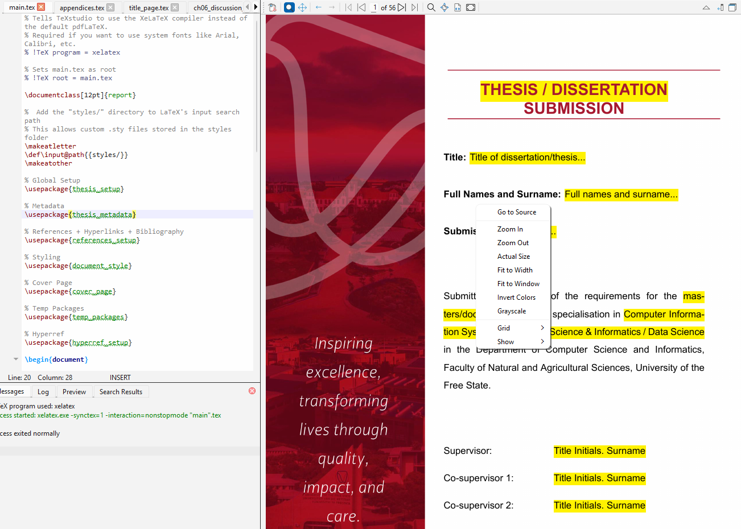
This prevents:
- Editing the wrong file
- Accidentally breaking global formatting
- Confusion about where content lives
You do not need to search for files manually.

🔹 3. Separation of Responsibilities
The template follows a strict separation:
File type | Purpose
main.tex | Controls structure and compilation
.sty / .cls files | Styling, layout, commands
Chapter .tex files | Content only
Cover page package | Title page logic only

Rule of thumb:
✏️ If you’re writing text → edit a chapter file
⚙️ If you’re changing layout → edit a style or class file

🔹 4. Faster Compilation with \includeonly
Large documents compile slowly. To speed things up while working, use:
\includeonly{chapters/chapter3}
This goes in main.tex, before \begin{document}.
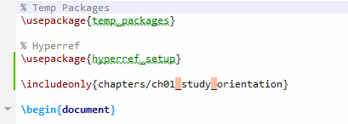
What this does:
- Compiles only the selected chapter
- Keeps page numbers, references, and formatting consistent
- Dramatically reduces compile time
When finished:
- Remove or comment out \includeonly
- Compile the full document again
✅ This is safe and recommended for day-to-day writing.

Summary Rules (Keep This in Mind)
- ✅ Always compile from main.tex
- ✅ Edit content via “Go to Source”
- ✅ Use \includeonly to work faster
- ❌ Do not compile chapter files directly
- ❌ Do not mix content and styling
This structure keeps the document stable, professional, and easy to maintain, even as it grows large.

🔹 5. How to add a new chapter?
- In TeXstudio: Click File → New
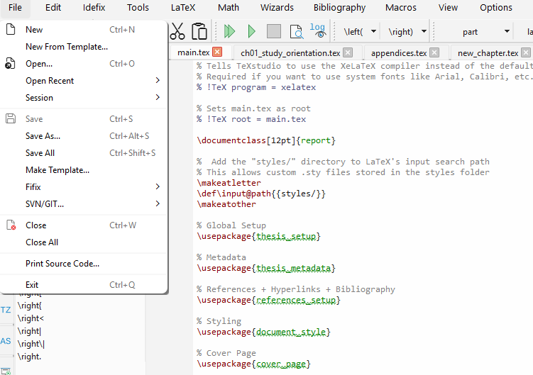
- A blank file called “untitled” will open. Add your text inside the blank file.
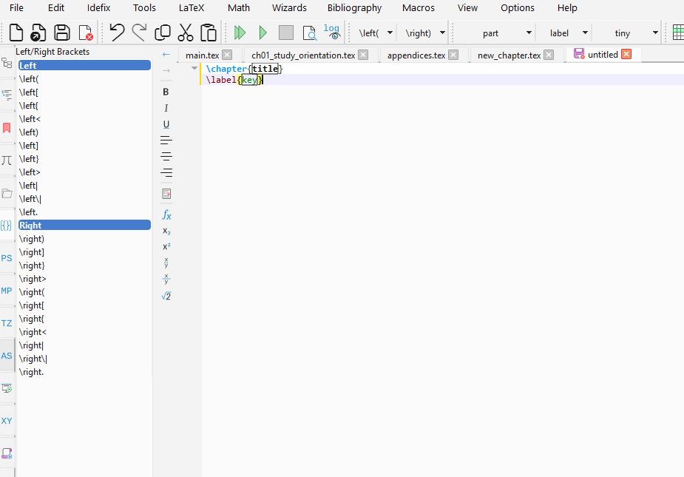
- In TeXstudio: Click File → Save As…
- Navigate to your project folder and Open the chapters folder:

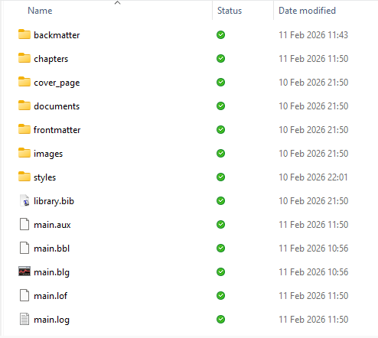
- Name the file, for example: new_chapter.tex
⚠️ Very important: Make sure it ends in .tex
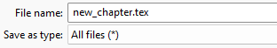
- Open main.tex.
- Scroll to where the other chapters are included.
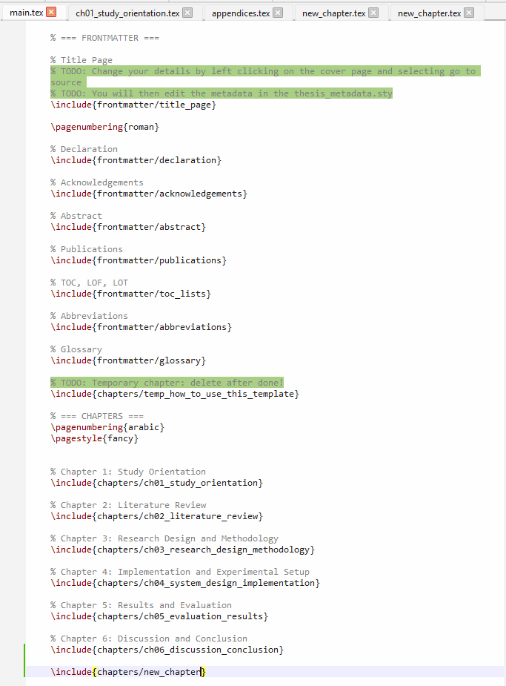
- Place your \include{chapters/new_chapter} line in main.tex exactly where you want the chapter to appear in the logical flow of your dissertation, since LaTeX prints chapters in the order they are listed there.
⚠️ Do NOT add .tex inside \include{}.

🔹 5. How to add references?
- Download Mendeley from https://www.mendeley.com/ and run the installer.

- Register via your institution.

- Drag and drop articles into the view or use the ‘+ Add references button’.
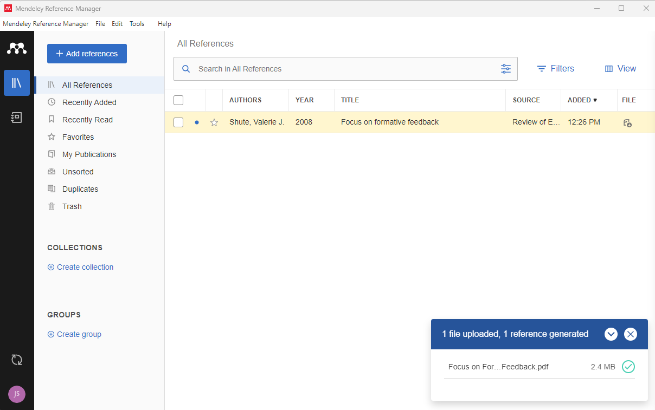
- To export: Click File → Export All → BibTeX (*bib)
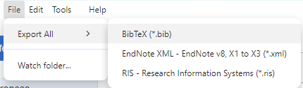
- Use File Explorer to open your project directory and replace the library.bib file with your new library.bib.

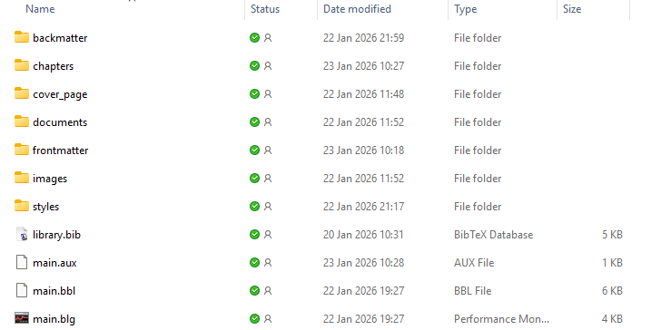
- Compile, and you are done!
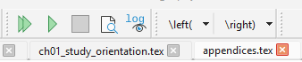

✨ Good luck and happy writing!

